| **Name : Yash Sarang** | **Class/Roll No. : 47** | **Grade :** |
| --- | --- | --- |

**Title of Experiment :** Creating a Wireframe on selected problem statements.

**Objective of Experiment :** The objective of this experiment is to design a wireframe for a user-friendly and efficient banking process on a bank's website. The wireframe will serve as a visual representation of the interface, allowing us to identify potential usability issues and streamline the banking experience.

**Outcome of Experiment :**  Created a Wireframe for the Pharmacy Website

**Problem Statement :** Create A Wireframe for Bank of India Website

**Description / Theory :**

A wireframe is a visual representation of the basic structure and layout of a web page, mobile app, or other digital product. It is a simple, skeletal outline that depicts the placement of key elements such as text, images, buttons, and navigation menus without including detailed design elements like colors, fonts, or graphics. Wireframes serve as a blueprint for designers and developers to plan and communicate the layout and functionality of a digital project before investing time in full-fledged design and development.

They help ensure that the user interface and user experience (UI/UX) are well-organized and user friendly. Wireframes can be created using specialized software or drawn by hand and are an essential tool in the early stages of the design process. Designing a wireframe for a user-friendly and intuitive mobile app interface is a complex task that often involves multiple stakeholders and varied design considerations.

**Wireframe:**

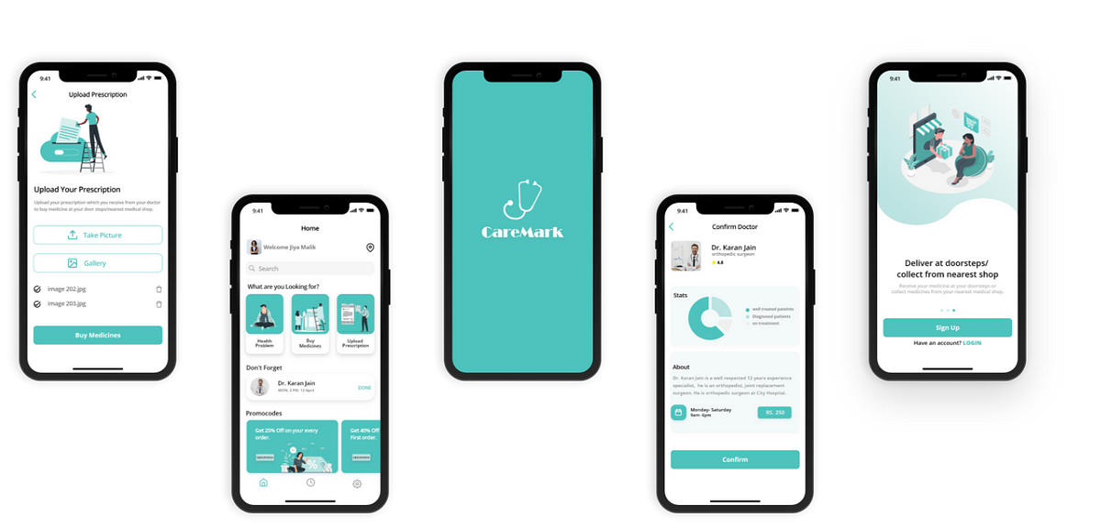



**Results and Discussions :**

Creating wireframes for the Bank of India website using Figma resulted in structured representations of key screens, including the Home Tab, Manage Cards, Pay Bills, Account Settings, and Money Transfer. Discussion centered around user experience, visual hierarchy, design consistency, responsiveness, user feedback, and compliance/security. The wireframes aim to ensure an intuitive, user-friendly, and secure digital banking experience for Bank of India customers. Refinements will be made based on stakeholder feedback and usability testing.

**\*\*\*\*\***